Meta title (63/65) | The Ultimate Guide to DNA in Skincare: Uses & Benefits | SKOON.
Meta description (127/155) | Find out how DNA testing is used to select products & ingredients to care for your unique skin type. Visit SKOON. to read more!
Slug | /guide-DNA-personalised-skincare
Keyword research | https://docs.google.com/spreadsheets/d/14oqtvmmNpK2oXlgm3Hnr5DNPXJ5luFAToCiaqei8hm8/edit?usp=sharing

Featured/Cover image:

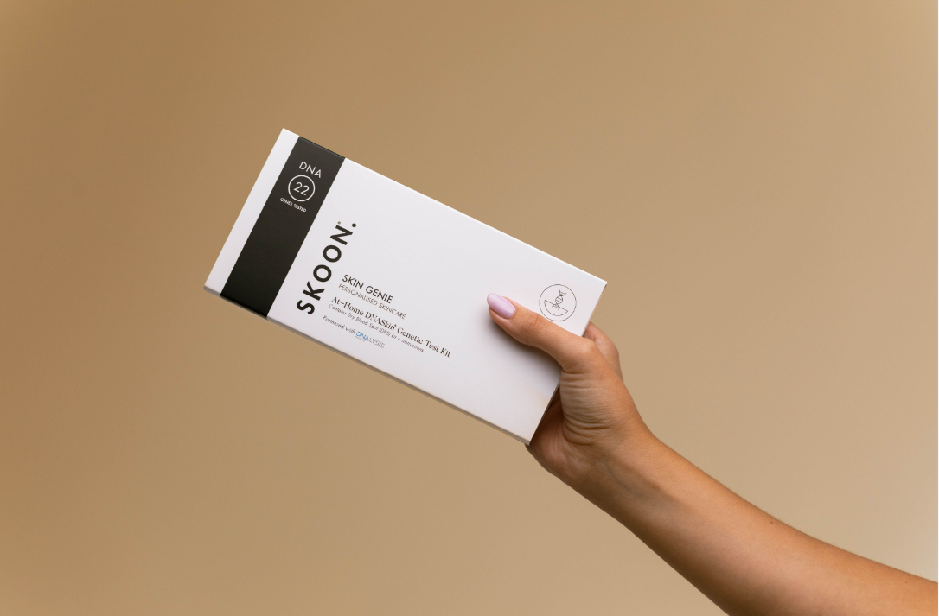

H1: The Ultimate Guide to DNA in Skincare: Uses & Benefits
If you're like most people, you probably think of DNA as something that exists inside of cells. But what if I told you that DNA could also be found in skincare products? Believe it or not, DNA plays a role in the health and appearance of our skin. Your genes exert a lot of control over how your skin looks and behaves, which is why it influences finding the right products for your specific skin concerns type of skin are so important.
In this ultimate guide to DNA in skincare, we'll take a look at the role of DNA in skincare, and we'll discuss some of the benefits of using products that contain this powerful molecule and the different ways that your genes can affect your complexion and give you tips on how to find the right products for you.
If you are like most people, you probably think of DNA as something that exists somewhere inside your cells or in major crime dramas. What if I tell you that your genes play a major role in the health and appearance of your skin?
In this ultimate guide to DNA in skincare, I’ll take a look at the role of DNA in skincare as well as discuss some of the major benefits of this powerful skin science. I will also touch on the different ways that your genes can affect your skin health and beauty and how knowledge of your unique DNA can help you find the right beauty products.

Table of contents {H2’s}

- What is DNA based skincare?
  - How genes influence your skin condition
Why DNA skin care is personalisable
How DNA can be related to skincare
- A brief overview: the history of DNA personalised Skincare
- How does DNA testing work in skincare?
- 4 benefits of using DNA to select the right skincare products
- What is our approach to utilising DNA testing to tailor a skincare regime for your skin type?
- Learn more about skincare and discover exceptional skincare products.

H2: What is DNA-based skincare?
As the name suggests, DNA-based skincare uses the molecule DNA to improve the health and appearance of the skin. But how does it work? Well, our DNA is responsible for producing proteins that are essential for the structure and function of our cells. By applying products that contain DNA to the skin, we can encourage the production of these proteins, which can help to improve the overall appearance of the skin.

As the name suggests, DNA-based skincare uses the science of genetics to guide you to a better understanding of your own unique skin.. But how does it work? Skin genetics is the scientific study of genes and heredity—of how certain qualities or traits passed from parents to offspring influence the health and appearance of your skin. This in-depth knowledge is invaluable to optimise your skincare. Think of it like this. DNA-based skincare is the ultimate “made-for-you” customised skincare.

DNA-based skincare
Skin genetics
Customised skincare

H3: How genes influence your skin condition
Our DNA is made up of genes, and each gene is responsible for a specific function in the body. For example, there are genes that control the production of collagen, which is a protein that helps to keep the skin looking firm and youthful. There are also genes that control the production of melanin, which is the pigment that gives our skin its colour.

H3: Why DNA skin care is personalisable
Since our DNA is unique to each of us, DNA-based skincare can be customised to our individual needs. By understanding our own genetic makeup, we can select the products that are most likely to be effective for our skin type and condition.

This personalised approach to skincare is one of the many reasons why DNA-based products are becoming increasingly popular.

Your DNASkin lab test examines 22 genetic markers across 6 categories associated with skin health and ageing:

- Elasticity
- Environmental Pollution
- UV-Ageing
- Hyperpigmentation & Sun Damage
- Breakouts
- Sensitivities



H3: How DNA can be related to skincare
As we age, our skin cells produce less collagen, and the resulting loss of elasticity can lead to wrinkles. But by using products that contain DNA, we can encourage the production of collagen, which can help to reduce the appearance of wrinkles.

In addition to its anti-aging properties, DNA also offers protection from the sun's harmful UV rays. Melanin is a pigment that helps to absorb UV light, and products that contain DNA can help to increase the production of melanin in the skin.

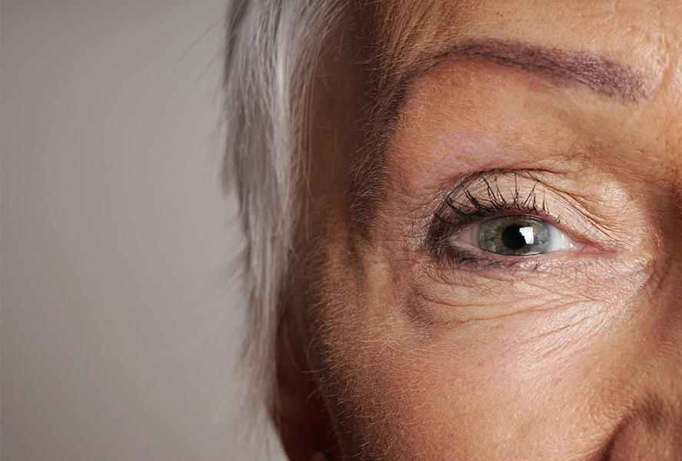

The trend of personalised beauty is nothing new, but there’s nothing quite like DNA-based skincare, which provides a hyper-personalised approach to allow you to take your skincare to the next level.
The results of DNA testing allows us to analyse and understand our genetics better in order to find the right ingredients to help us maintain our skin, and prevent issues we are inherently prone to.
DNA testing allows top skincare professionals to create highly targeted routines that target the conditions and issues for which your skin is already predisposed - including conditions you may not be aware of yet.
The role of genetics has much more influence on our lives than we usually realise, with recent studies indicating that our genetics account for around 50% of ageing.
This means, your genetics are often responsible or have a great deal of influence over the composition of your skin and the issues or symptoms for which you are predisposed.


H2: A brief overview: the history of DNA personalised Skincare
The use of DNA testing to personalise skincare is a recent trend, but as early as 2018, the DNA based skincare products market was valued at a whopping 7.4 USD billion.

It is estimated that the industry will grow to new heights, as skincare consumers continue to appreciate a bespoke and highly customised approach to skincare solutions.

DNA based skincare allows brands to form an even closer relationship with their customers, and provide better results from recommending the right products and ingredients.

A key factor in the growth of this industry niche is the availability, reduced time to obtain DNA results, and lower cost of DNA tests. Where DNA tests used to be scarce, expensive and take weeks to process, in some countries (USA), DNA results are now commercially available within 24-72 hours for under $100.

Of course, this doesn’t go for all types of DNA related tests in all countries, and DNA related tests in South Africa for skincare insights can take anywhere from 14 days to around 2 months for your results and recommendations to arrive, after submitting your sample.



H3: Which products are most popular in DNA personalised skincare?
One of the fastest-growing product types in the DNA based skincare industry, and a key recommendation, is serums. Serums are seeing a rising demand due to their potent compositions, light and absorbent properties and their key anti-ageing benefits (such as Vitamin C serums).

Serums also provide benefits for the skin ranging from lightening dark marks (consistent with hyperpigmentation), improving barrier skin repair (sensitivities and environmental pollution) and boosts hydration and suppleness.

They are likely to form a core component of product recommendations given by brands that approach skincare from a DNA based perspective.

In most parts of the world, DNA based skincare as a trend is still emerging and expanding. It attracts educated skincare consumers that are tired of an ineffective, one size fits all approach to skincare, and require clinically proven results.

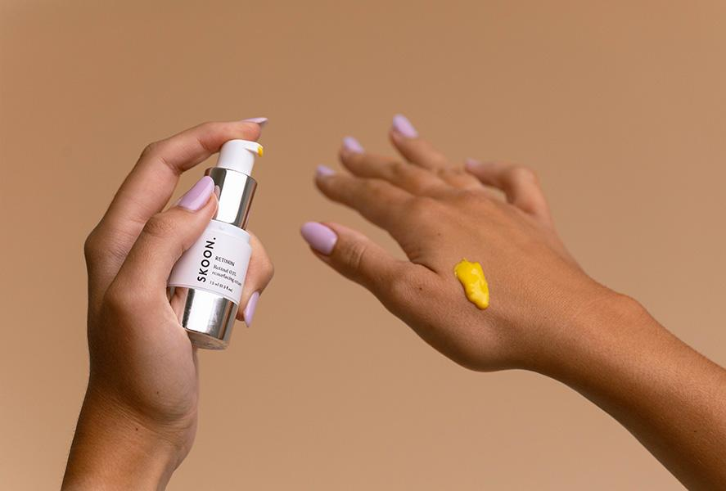

H2: How does DNA testing work in skincare?
The process behind prescribing skincare products to customers based on their DNA is relatively straightforward. The brand will send a DNA collection kit to the customer, which requires a DNA sample in the form of a swab to be taken, sealed and sent back to the brand.
The brand, either independently or in partnership with a specialised lab, will analyse the sample based on genetic markers and various testing categories and use the insights gleaned from your sample, to map out a hyper-technical skincare routine.
More specifically, a lab analyses portions of your DNA known as SNPs (pronounced "snips") - single nucleotide polymorphisms - which are what make your DNA unique.
Following the testing phase, products are recommended based on your specific skin type, and you may be provided with a basic or complete report that covers a wide range of insights related to your skin, based on your genetic composition/code.
Pairing your skincare approach with concrete insights into your skin from a genetic perspective provides your skin with a range of benefits.
Genetic screening is the future of preventative medicine, as genetic testing uncovers a wide range of insights that can help you make informed decisions related to your habits, diet and nutrition, fitness and physical training and more.
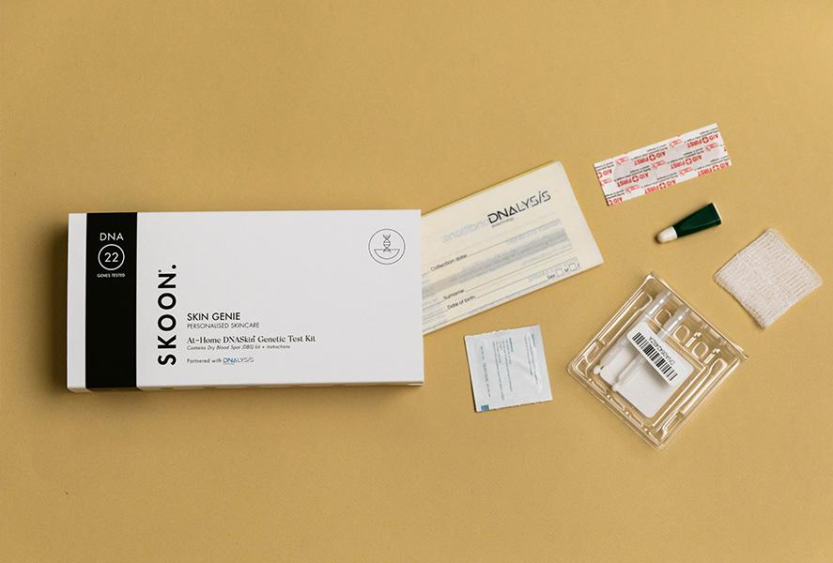

H2: 4 Benefits of using DNA to select the right skincare products
We’ve already mentioned that DNA based skincare is hyper-personalised and tailored around your genetic code - but what are the actual benefits of this highly customized approach to skincare?
Your lifestyle is only responsible for around 40-50% of your skin health, and managing your habits is hard enough.
Lifestyles are fluid and ever-evolving, whereas genetic code is consistent and is a completely objective indicator.
Half the battle is understanding the factors that influence your skin health from a genetic perspective.
Let’s find out about the specific benefits that DNA based skincare has to offer.


DNA testing allows you to tailor a skincare routine properly
DNA testing takes into account specific genetic markers and allows you to provide tailored, targeted care and maintenance for your skin.

DNA based skincare allows you to uncover and identify your skin’s susceptibility to certain conditions, and by analysing your skin based on various skin factors, you can uncover which skin concerns you are prone to.

Having a comprehensive grasp of your skin type and predisposed skin concerns ensures that you can take action in the present, and provide your skin with preventative treatments to maintain aspects of your skin that might pose a future concern.

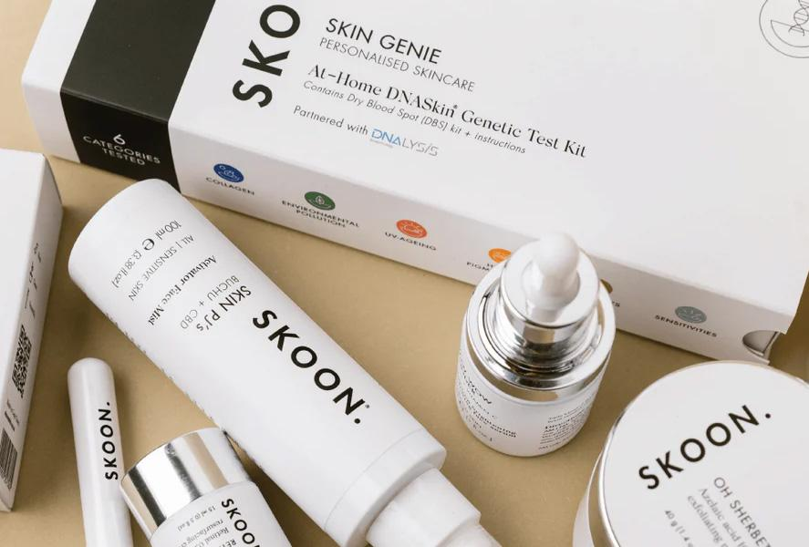

Maintain healthy skin by choosing the right ingredients based on DNA evidence
The fact of the matter is that skincare concerns like sagging, wrinkling and inflammation are intrinsically linked to your genetic make-up - largely because the skin consists of various proteins and molecules produced by your DNA.
Your DNA produces proteins through a two-step process. First, the DNA is transcribed to mRNA - a single strand form of DNA that carries instructions for which proteins cells should make. Second, the mRNA instruction is read by ribosomes which build the proteins specified by the instruction in a process called translation.

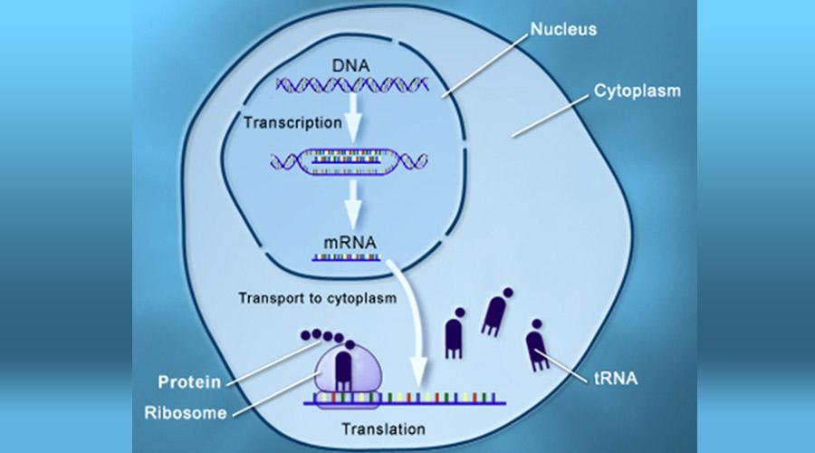

Collagen and elastin are two such proteins responsible for the foundation of our skin’s structure in the dermal layer, and deficiencies in these (and other) proteins can, for example, lead to visible and underlying skin issues.
- Collagen is a group of proteins found mainly in the connective tissue of your skin and provides strength and elasticity to your skin. Collagen is not that flexible in nature.
- Elastin is a protein created by fibroblasts which form a chain of elastic fibre. These elastin fibres maintain your skin’s elasticity and firmness. It also helps skin to return to its original status after being poked or pinched.

A deficiency of both collagen and elastin results in inelasticity, sagging skin and wrinkles.

Understanding the precise cause and deficiency of proteins in your skin allows you to seek the correct, specific treatment. It also, in some cases, allows for the correct level of supplementation required, rather than guessing and overexposing the body or skin to high levels of a single nutrient (which may cause (further) damage or stress.
DNA testing can define any skin-related deficiencies allowing you to counteract issues and maintain proper function of the skin.

Discover the way your skin will age

Analysing your genetic code gives you greater insight into your family tree and more comparative data points that can allow you to cover more consistent trends associated with the way in which your skin will age.

DNA testing will also allow you to analyse your susceptibility/risk to AGEs, or Advanced Glycation End-products which undergo glycolysis as a result of exposure to sugars.

This process inhibits the natural function of a protein, which in turn leads to swift ageing effects that impact the skin.

AGEs can build up on aged tissues and are a biomarker of degenerative diseases and other chronic health conditions. They can also spark skin-related conditions or changes in skin characteristics.



Uncover & resolve underlying skin damage & cells
Not all skin damage is visible on the surface - like a classic case of dry skin with cracking and peeling. Some skin damage lies well beneath the surface, as the skin is comprised of several important layers and billions of cells that provide a range of functions.
With genetic testing, hundreds of metrics have been used to analyse and determine issues and deficiencies in your body which influence skin characteristics.
For example, you could have genetic predispositions to certain skin conditions, and even types of skin cancers, as well as pigmentation caused by UV damage. On the other hand, you may also have genes that offer enhanced solar protection as part of your natural genetic solar protection factors.
Understanding the underlying susceptibility to skin damage is key to forming the right skincare routines and lifestyle habits to treat or avoid these conditions.
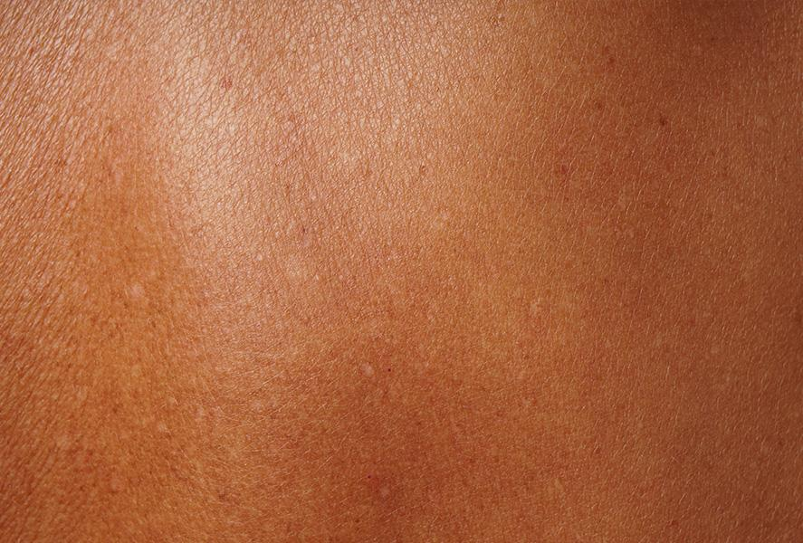

H2: What is our approach to utilising DNA testing to tailor a skincare regime for your skin type?
SKOON.’s vision for DNA testing and skincare personalisation has been realised as a result of our collaboration with DNAlysis, coupled with our scientific and personalised skincare approach.
DNAlys is a sophisticated biotechnology company based in South Africa that is focused on personalising healthcare based on genetics.
Samples that are collected from SKOON. customers are analysed based on 18 genetic markers (SNPs) in 6 categories associated with skin defects and ageing.
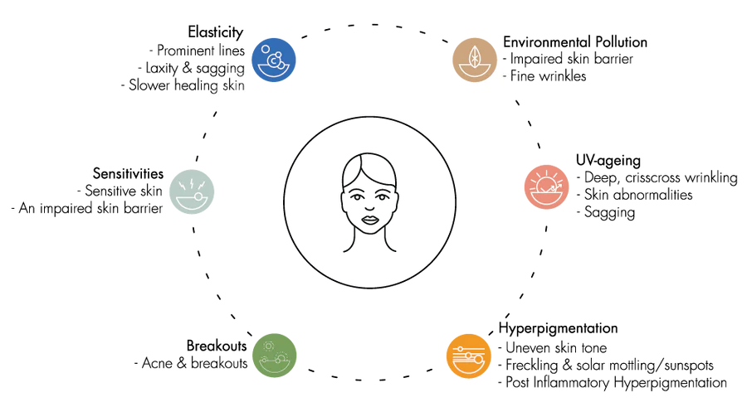

6 Focus Needs | Skin Concerns
- Elasticity | Collagen, sagging & wrinkles
- Environmental Pollution | Antioxidant response & oxidative stress
- Photoaging | UV damage repair & sun-related abnormalities
- Hyperpigmentation | Solar mottling, post-inflammatory hyperpigmentation, freckles.
- Sensitive | Sensitivities (rosacea, eczema, etc)
- Breakouts | Detoxification, breakouts

Following the DNA testing phase, you are provided with a comprehensive e-report that covers a wide range of insights related to your skin, based on your genetic composition. You’ll also be recommended products tailored for your specific DNA results and skin type. A dedicated member of the SKOON. team will provide a consultation to help you explore what we’ve uncovered and provide you with any further information.

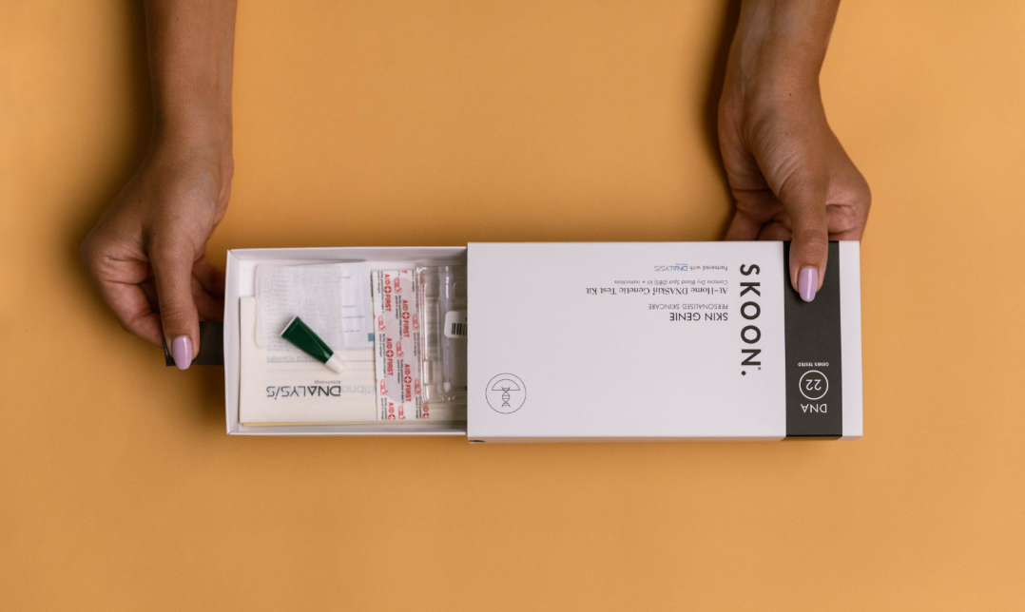

H2: Learn more about skincare and discover exceptional skincare products.

H3: Our range is clean, scientifically formulated and ethically produced.
SKOON. Believes in and utilises a scientific approach to skincare, discovering and sourcing the highest quality international and local ingredients to develop clean, and effective formulations.
We also embody ancestral African beauty, valuing the communities responsible for providing their knowledge of incredible ingredients that are cultivated natively and form the basis of our modern, scientific-led formulations.
Our skincare range includes a wide range of topical skincare products appropriate for a variety of skin types (dry, combination, oily, normal), and also features cutting edge beauty smoothies (nutricosmetics) which are packed with potent antioxidants, vitamins and minerals that provide key health and skin benefits and are able to help treat skin concerns preemptively from the inside out.
SKOON has launched Trial Kits to allow you to try-before-you-buy!
Our blog is also home to a wide variety of resources that cover everything skincare related. From ingredient guides covering the benefits of hero ingredients such as Vitamin A (retinol), rosehip oil, hyaluronic acid and azelaic acid, to our ultimate guides to help you with acne control, dry and sensitive skin, treating hyperpigmentation, and determining your skin type.

References for this information:

https://www.grandviewresearch.com/industry-analysis/dna-based-skin-care-products-market
Human Microbiome Journal, June 2017, pages 7–13
Dermatologic Therapy, February 2017, pages 926–935
International Journal of Molecular Science, January 2017, page 18 and June 2013, pages 12,222-12,248
Journal of Cosmetic Dermatology, February 2017, ePublication
Annals of Internal Medicine, June 2013, pages 781-790
Photochemistry and Photobiology, March-April 2011, pages 452-456
Journal of Photochemistry and Photobiology, August 2017, pages 551–559
Journal of Clinical and Aesthetic Dermatology, January 2013, pages 16–26
British Journal of Dermatology, February 2010, pages 415–419; and April 2007, pages 716–719
Stem Cells Translational Medicine, September 2013, pages 638–640
Current Opinion in Plant Biology, February 2011, pages 4–9

